Game Overview:

Game Architecture
Layer | Component / Module | Function & Location
User/Player | - Upper Secondary Students (Form 4 & 5)  - Teachers | - Both user categories have distinct access levels and specific system roles.  - The system supports both a quick "Guest Mode" for trial gameplay and a secure "Sign-In Mode" to save progression and track history syllabus mastery.
Infrastructure | - Game Engine  - Version Control  - Database  - Hosting | - Game Engine: Godot Engine 4.x (GDScript). Chosen because it is 100% free, excellent for 2D games, and exports perfectly to web browsers (HTML5).  - Version Control: Git & GitHub. Used to safely store code and allow the team to work together without overwriting each other's work.  - Database: MySQL 8.x for the main game backend (accounts/progress). JSON (JavaScript Object Notation) acts as a lightweight, easily editable local database for the trivia questions.  - Hosting: Shared Microsoft Server / GitHub Pages. (GitHub Pages will be exclusively used to host the 8-week playable prototype).
Game Module | Module 1: Authentication | - Built using Godot Control nodes for the UI (Login/Register screens).  - Utilizes Godot's HTTPRequest node to send secure credentials to the external backend database.
Game Module | Module 2: Overworld & HUD | - Implemented using 2D TileMap nodes for the historical environments and a CharacterBody2D node for player movement.  - The HUD uses a persistent CanvasLayer to continuously display the player's Level and Coins across different scenes.
Game Module | Module 3: Pre-Combat | - Functions as a transition scene managing Game States.  - Loads 2D character sprite assets into memory so the player can select their historical Action Figure before the battle scene is instantiated.
Game Module | Module 4: Combat (Core) | - The most resource-intensive module. Uses built-in Timer nodes for the strict countdown mechanics.  - Features a local script that parses the JSON trivia database file to randomize questions and checks answers in real-time.  - Handles API calls to Gemini for processing open-ended answers.
Game Module | Module 5: Progression | - A background logic controller that calculates EXP and Syllabus Mastery marks after a match.  - Physically writes save data to the player's local storage (user://save_data.json) and pushes updates to the cloud database.
Game Module | Module 6: Multiplayer (Ph 2) | - Contains the networking architecture for the PVP Room System.  - Will utilize WebSocket connections or REST API polling to sync the combat state (HP, questions answered) between multiple clients in real-time.
Integration | - Gemini API  - System Analytics | - Gemini API: Integrated to dynamically evaluate and grade students' answers for open-ended history questions.  - Analytics: Processes the trivia data to allow teachers to analyze student performance and monitor cognitive retention.
Asset Pipeline (AI & Creative Tools): | - Logic & Writing  - Visuals  - Audio | - Logic & Writing: Claude Pro (~RM94/month) is used to help brainstorm code logic, balance game design, and format the KSSM trivia questions.  - Visuals: Midjourney (~RM47/month) and Recraft.ai (~RM94/month) are used to generate the base character and background concepts. Krita (a free drawing software) is used to manually clean up the AI art, fix pixel inconsistencies, and prepare assets for the game engine.  - Audio: Suno AI (~RM47/month) is used to create catchy, culturally appropriate background music (BGM). ElevenLabs is used to generate high-quality voice lines or dynamic sound effects (SFX).

Game Main Component
- Module 1: Authentication & User Management Manages secure player access, handling account registration, login verification, and password recovery. It acts as the necessary gateway to link a player to their saved progress and profile.
- Module 2: Overworld Map & HUD Serves as the central 2D interactive hub where players navigate their avatar to explore historical environments and access different game modes (houses). The Heads-Up Display (HUD) persistently tracks real-time stats like Level, EXP, and Coins.
- Module 3: Pre-Combat Preparation The setup phase that bridges map exploration and battle. It handles the transition logic and allows players to strategically select their desired historical Action Figure (avatar) before entering the arena.
- Module 4: Combat Mechanics (The Main Mini-Game) The core "Trivia Combat" loop. Players must answer KSSM History questions (MCQ or Open-Ended) within a strict time limit. Correct answers trigger attack animations to reduce the enemy's HP, while wrong answers or timeouts result in taking damage.
- Module 5: Progression System Tracks and rewards player achievement after every match. It calculates awarded coins, converts them into Experience Points (EXP) for account level-ups, and logs the player's correct/incorrect answers to track their KSSM Syllabus Mastery.
- Module 6: Multiplayer (PVP Room System) The network-based social mode (Phase 2) that allows players to host or join custom lobbies using alphanumeric Room Codes. It scales to support team battles ranging from 1v1 up to 4v4 using the standard trivia combat mechanics.

Development Environment:
Game framework ni byk dok bukan mcm software
Component | Technology
Game Engine | Godot Engine
Programming Language | GDScript
Database | MySQL 8
Web Server | Github Pages
OS | Desktop: Windows, macOS, Linux, and BSD.  Mobile/Tablet: Android and iOS.  Web: HTML5 / WebAssembly.
Version Control | Github, Git
IDE | Godot Engine
Asset Builder | Godot Engine, Claude MCP, Midjourney, Pixellab, Other Asset Builder

Game Architecture Design

Logical Architecture
1. Main Layers & Components
- i. Frontend (Presentation / Client-Side): Godot Engine 4.x exported to HTML5/WebAssembly so the game can be played directly in web browsers. This component manages the UI/UX display, such as the login screen (mockup), 2D Map (Overworld Map), HUD Menu (Level, XP Bar, Coins), Combat Interface (HP bar, timer, question box), and Post-Match Summary screen. The display is locked at a 1280x720 resolution (16:9 aspect ratio) utilizing a 2D pixel art style.
- ii. Backend (Application / Game Logic): GDScript (Godot's programming language) handles the core game loop logic. This includes the logic for the Combat System (damage calculation, 10-second timer, HP reduction), Progression System (awarding coins, leveling up, KSSM syllabus mastery tracking), and Input Management across devices (mouse clicks, keyboard shortcuts, and touch controls).
- iii. Data (Storage & Database): A JSON file (trivia_data.json) acts as the primary database to store trivia questions, allowing for easy updates without altering the game code. Browser Local Storage is used to save player profiles and handle session recovery for the MVP phase, while a SQL database is planned for game database management on a larger scale.
2. Supporting Services
- i. Audio Management: Playback management for high-quality background music (BGM) and sound effects (SFX) generated via Suno AI and ElevenLabs, complete with an accessible mute/unmute button control system.
- ii. Asset & Load Management: Management of game file loading, where the total exported file size must be kept under 50MB to ensure loading times remain under 5 seconds on the Itch.io platform.
- iii. Error Handling & Recovery: A service that monitors internet connection drops or failures in loading the JSON file, displaying clear, user-friendly error messages (e.g., "Failed to load questions") instead of allowing the system to freeze or crash.
- iv. AI Integration API (Phase 2): API communication with a backend AI engine to evaluate and grade the factual accuracy of open-ended text input answers in real time.
- v. Multiplayer / Network Services (Phase 2): Network services to manage server communication for PVP Room Creation, Room Code generation, random matchmaking, and real-time combat synchronization for 1v1 up to 4v4 match formats.

Physical Architecture (High):

Game Architecture
Layer | Component / Module | Function & Location
User/Player | - Upper Secondary Students (Form 4 & 5)  - Teachers | - Both user categories have distinct access levels and specific system roles.  - The system supports both a quick "Guest Mode" for trial gameplay and a secure "Sign-In Mode" to save progression and track history syllabus mastery.
Infrastructure | - Game Engine  - Version Control  - Database  - Hosting | - Game Engine: Godot Engine 4.x (GDScript). Chosen because it is 100% free, excellent for 2D games, and exports perfectly to web browsers (HTML5).  - Version Control: Git & GitHub. Used to safely store code and allow the team to work together without overwriting each other's work.  - Database: MySQL 8.x for the main game backend (accounts/progress). JSON (JavaScript Object Notation) acts as a lightweight, easily editable local database for the trivia questions.  - Hosting: Shared Microsoft Server / GitHub Pages. (GitHub Pages will be exclusively used to host the 8-week playable prototype).
Game Module | Module 1: Authentication | - Built using Godot Control nodes for the UI (Login/Register screens).  - Utilizes Godot's HTTPRequest node to send secure credentials to the external backend database.
Game Module | Module 2: Overworld & HUD | - Implemented using 2D TileMap nodes for the historical environments and a CharacterBody2D node for player movement.  - The HUD uses a persistent CanvasLayer to continuously display the player's Level and Coins across different scenes.
Game Module | Module 3: Pre-Combat | - Functions as a transition scene managing Game States.  - Loads 2D character sprite assets into memory so the player can select their historical Action Figure before the battle scene is instantiated.
Game Module | Module 4: Combat (Core) | - The most resource-intensive module. Uses built-in Timer nodes for the strict countdown mechanics.  - Features a local script that parses the JSON trivia database file to randomize questions and checks answers in real-time.  - Handles API calls to Gemini for processing open-ended answers.
Game Module | Module 5: Progression | - A background logic controller that calculates EXP and Syllabus Mastery marks after a match.  - Physically writes save data to the player's local storage (user://save_data.json) and pushes updates to the cloud database.
Game Module | Module 6: Multiplayer (Ph 2) | - Contains the networking architecture for the PVP Room System.  - Will utilize WebSocket connections or REST API polling to sync the combat state (HP, questions answered) between multiple clients in real-time.
Integration | - Gemini API  - System Analytics | - Gemini API: Integrated to dynamically evaluate and grade students' answers for open-ended history questions.  - Analytics: Processes the trivia data to allow teachers to analyze student performance and monitor cognitive retention.
Asset Pipeline (AI & Creative Tools): | - Logic & Writing  - Visuals  - Audio | - Logic & Writing: Claude Pro (~RM94/month) is used to help brainstorm code logic, balance game design, and format the KSSM trivia questions.  - Visuals: Midjourney (~RM47/month) and Recraft.ai (~RM94/month) are used to generate the base character and background concepts. Krita (a free drawing software) is used to manually clean up the AI art, fix pixel inconsistencies, and prepare assets for the game engine.  - Audio: Suno AI (~RM47/month) is used to create catchy, culturally appropriate background music (BGM). ElevenLabs is used to generate high-quality voice lines or dynamic sound effects (SFX).

Application Layer
This part outlines the application layer architecture of the Godot Engine. Godot employs a composition-based, hierarchical paradigm. This architecture relies on modular components organized into a strict tree structure, facilitating scalable and decoupled interactive application development.
1. Node-Based Composition (Nodes)
The fundamental atomic unit of the Godot architecture is the Node. Rather than utilizing monolithic controllers, Godot assigns single, specific responsibilities to individual nodes (e.g., rendering a 2D sprite, processing physics, or handling audio playback). Nodes are object-oriented entities that can be extended by attaching Scripts (typically GDScript or C#). These scripts define the behavioral logic and lifecycle processes (such as per-frame updates) for that specific node.
2. Hierarchical Structure (The Scene Tree)
During runtime, all active nodes are organized into a strict hierarchical data structure known as the Scene Tree. This tree is managed by a Root Node. The Scene Tree is responsible for orchestrating the execution loop; it iterates through its branches every frame to process inputs, calculate physics, and render graphics. Because the hierarchy is strictly structural, any spatial or logical transformations applied to a parent node are inherently inherited by its child nodes.
3. Modular Encapsulation (Scenes)
In this architecture, a Scene represents a localized, encapsulated branch of the Scene Tree that has been serialized and saved to the disk. Scenes allow developers to group multiple nodes into a cohesive, reusable module (e.g., a "Player" or a "User Interface"). These scenes function as templates and can be instanced multiple times within other scenes. This approach promotes high reusability and allows a complex application to be constructed entirely from nested, modular components.
4. Event-Driven Communication (Signals)
To maintain structural decoupling, Godot utilizes an event-driven communication model called Signals. Signals are an implementation of the Observer design pattern. Instead of nodes maintaining direct references to one another—which creates rigid dependencies—a node will emit a signal when a specific event occurs (such as a collision or a button press). Other nodes or scripts can dynamically subscribe to these signals and execute functions in response. This ensures that distinct systems, such as user interface and core gameplay logic, remain strictly separated.
5. Data Management (Resources)
The architecture clearly separates execution logic from static data. While Nodes process logic and exist within the active Scene Tree, Resources are passive data containers stored on the disk. Resources include media assets (audio, images, 3D models) as well as custom data structures (such as character statistics). Multiple nodes can reference a single Resource in memory simultaneously, ensuring efficient memory management and data consistency across the application.

Module & Interface Design

Module 1: Authentication & User Management
- Purpose
To provide a secure and reliable entry point for users (Students and Teachers) to register, log in, and link their game progress to their cloud profile.
- Functional Requirements (FR List)
- FR-AUTH-01 (Landing Page): System displays the main login interface. Actor: Guest/Player
- FR-AUTH-02 (Registration): System processes new account creation. Actor: Guest
- FR-AUTH-03 (Login): System authenticates credentials. Actor: Player/Teacher
- Interface Design
- Component: Application logo, text input fields (Username, Password), "Log In" button, "Sign Up" button, Guest mode hyperlink.
- Example/Sketch:
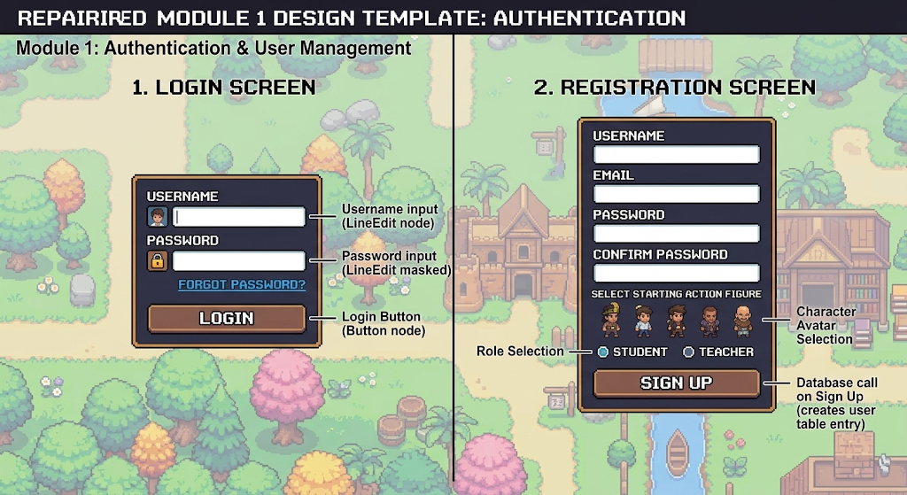

- Data Flow Diagram (DFD): User Inputs Data ➔ Godot Client Validates Format ➔ HTTP POST Request ➔ Backend Auth Server ➔ Returns Success Token ➔ Grants Access to Map.
- DB Table: users
  - Columns: user_id (PK), username, password_hash, role (student/teacher), created_at.
- UI/UX Consideration
- Provide immediate visual feedback (red outline or text) if login fails.
- Password input must be masked using asterisks (*).
- The "Login" button should be disabled (grayed out) until both input fields have text to prevent API spamming.
- Execution Notes
- Built entirely using Godot Control nodes (specifically VBoxContainer for alignment and LineEdit for inputs).
- API communication will be handled using Godot’s HTTPRequest node connected to the chosen backend (e.g., MySQL/BaaS).

Module 2: Overworld Map & HUD
- Purpose
To serve as a 2D interactive lobby where players can navigate their avatar, explore historical environments, view their stats, and access different game modes.
- Functional Requirements (FR List)
- FR-HUB-01 (Player Spawning): Render map and place player at coordinates. Actor: Player
- FR-HUB-03 (Menu Bar/HUD): Persistent display of level, EXP, and coins. Actor: Player
- FR-HUB-04 (Interactive Assets): Popup triggers when approaching buildings. Actor: Player
- Interface Design
- Component: Top-left HUD (Avatar icon, Level text, EXP progress bar), Top-right HUD (Coin counter), 2D map background, interactive floating exclamation marks (!) above buildings.
- Example/Sketch:
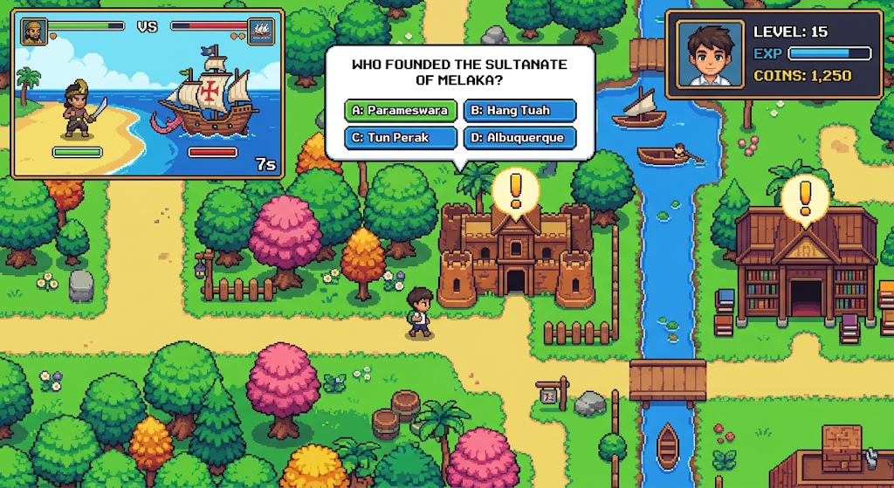
- Data Flow Diagram (DFD): Player Movement (WASD) ➔ Engine Updates X/Y Coordinates ➔ Player Collides with Building Area2D ➔ Triggers UI Popup.
- DB Table: player_progress
  - Columns: user_id (FK), current_level, total_coins, total_exp, last_map_x, last_map_y.
- UI/UX Consideration
- The HUD must remain persistently on the topmost layer, unaffected by the 2D camera movement.
- Camera must smoothly follow the player using Camera2D smoothing features to prevent motion sickness.
- Execution Notes
- Environment built using Godot TileMap node.
- Player controlled via CharacterBody2D with physics processing (_physics_process).
- HUD must be placed inside a CanvasLayer node so it stays anchored to the screen.

Module 3: Pre-Combat Preparation
- Purpose
To manage the transition phase between the Overworld and the Combat Arena, allowing players to strategically select their unlocked historical avatar (Action Figure) and view topic details.
- Functional Requirements (FR List)
- FR-PRE-01 (Mode Selection): Transition logic from map to lobby. Actor: Player
- FR-PRE-02 (Character Selection): UI to browse and select action figures. Actor: Player
- Interface Design
- Component: A horizontal scrolling carousel or grid of character cards. Each card displays the character's portrait, name, and a brief historical lore snippet. "Confirm" and "Back" buttons.
- Example/Sketch:
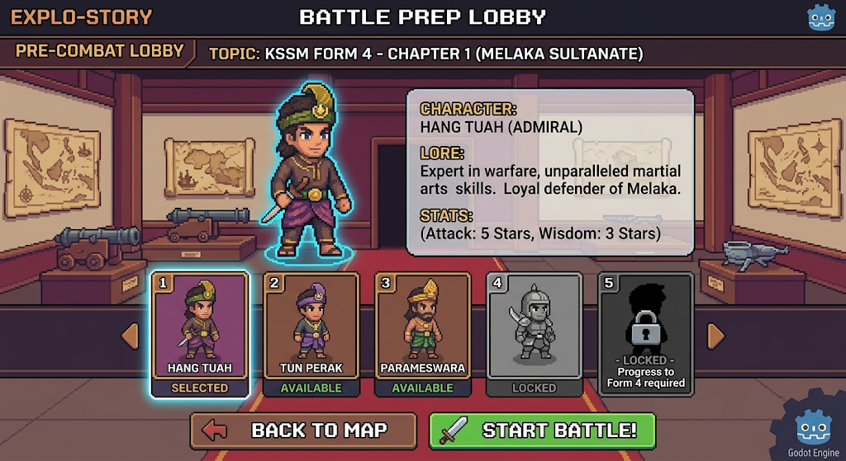
- Data Flow Diagram (DFD): Player Selects Card ➔ System Highlights Card ➔ Clicks Confirm ➔ Save Selected ID to Global Memory ➔ Load Combat Scene.
- DB Table: unlocked_characters
- Columns: user_id (FK), character_id, is_unlocked (Boolean).
- UI/UX Consideration
- Locked characters should be silhouetted in black or displayed with a padlock icon.
- Selected character must have a glowing border outline to clearly indicate the active choice.
- Execution Notes
- Use GridContainer or ScrollContainer for character rosters.
- The selected character data must be stored in a Godot Autoload (Singleton) script so the chosen sprite can be successfully passed into the next Scene (Combat).

Module 4: Combat Mechanics (The Main Mini-Game)

1. Purpose & Functional Requirements
The primary purpose of Module 4 is to execute the core "Trivia Combat" loop. Players must answer KSSM History questions within a strict time limit, where correct answers trigger attack animations to reduce enemy HP, and wrong answers or timeouts result in taking damage.
- FR-COM-01 (Trivia Generation): The system randomizes questions by parsing the JSON database file. Actor: Player
- FR-COM-02 (Combat Timer): The system enforces a strict 10-second countdown using built-in Timer nodes. Actor: Player
- FR-COM-03 (Answer Evaluation): The system checks answers in real-time and handles API calls to Gemini for processing open-ended answers. Actor: Player
- FR-COM-04 (HP & Combat Mechanics): Correct answers trigger attack animations to reduce the enemy's HP. Wrong answers or timeouts result in taking damage. Actor: Player
2. Interface Design

- Components: The Combat Interface manages the display of the HP bar, timer, and question box. This display is locked at a 1280x720 resolution utilizing a 2D pixel art style.
- Example/Sketch: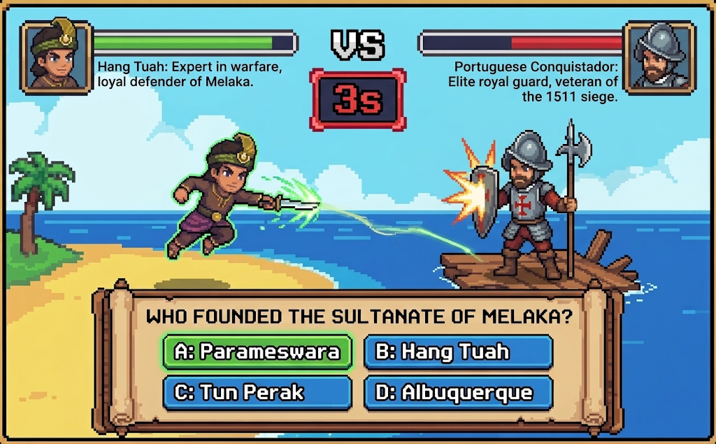(Visualizing 2D avatars on opposite sides, HP bars on top, a central 10-second timer, and a dialogue box at the bottom containing the question).
- Data Flow Diagram (DFD): Read trivia_data.json ➔ Display Question & Start Timer ➔ Player Submits Answer ➔ Validate via local script or Gemini API ➔ Trigger Attack Animation ➔ Update HP.
- Database Storage: This module relies on a JSON file (trivia_data.json) that acts as a lightweight, easily editable local database for the trivia questions.
3. UI/UX Considerations
- The timer must feature prominent visual cues (e.g., turning red or pulsating) during the final seconds to emphasize the strict time limit mechanics.
- Provide immediate and satisfying auditory feedback using the high-quality dynamic sound effects generated via ElevenLabs.
4. Execution Notes
- As the most resource-intensive module, you must carefully manage the built-in Timer nodes to ensure the countdown mechanics run smoothly without lag.
- A local script handles real-time answer checking by parsing the JSON file, while the Gemini API integration evaluates students' open-ended history answers.

Module 5: Progression System
1. Purpose & Functional Requirements
The primary purpose of Module 5 is to track and reward player achievement after every match. It calculates awarded coins, converts them into Experience Points (EXP) for account level-ups, and logs the player's correct and incorrect answers to track their KSSM Syllabus Mastery.
- FR-PROG-01 (Match Calculation): The system calculates awarded coins and Experience Points (EXP) after every match. Actor: System
- FR-PROG-02 (Account Progression): The system converts earned EXP to manage account level-ups. Actor: System
- FR-PROG-03 (Syllabus Tracking): The system logs the player's correct and incorrect answers to track their KSSM Syllabus Mastery. Actor: System
- FR-PROG-04 (Data Persistence): The system physically writes save data to the player's local storage and pushes updates to the cloud database. Actor: System
2. Interface Design
- Components: The Post-Match Summary screen displays earned Coins, EXP gained, a visual EXP progress bar, new Account Level, and KSSM Syllabus Mastery statistics (correct vs. incorrect ratio).
- Example/Sketch: 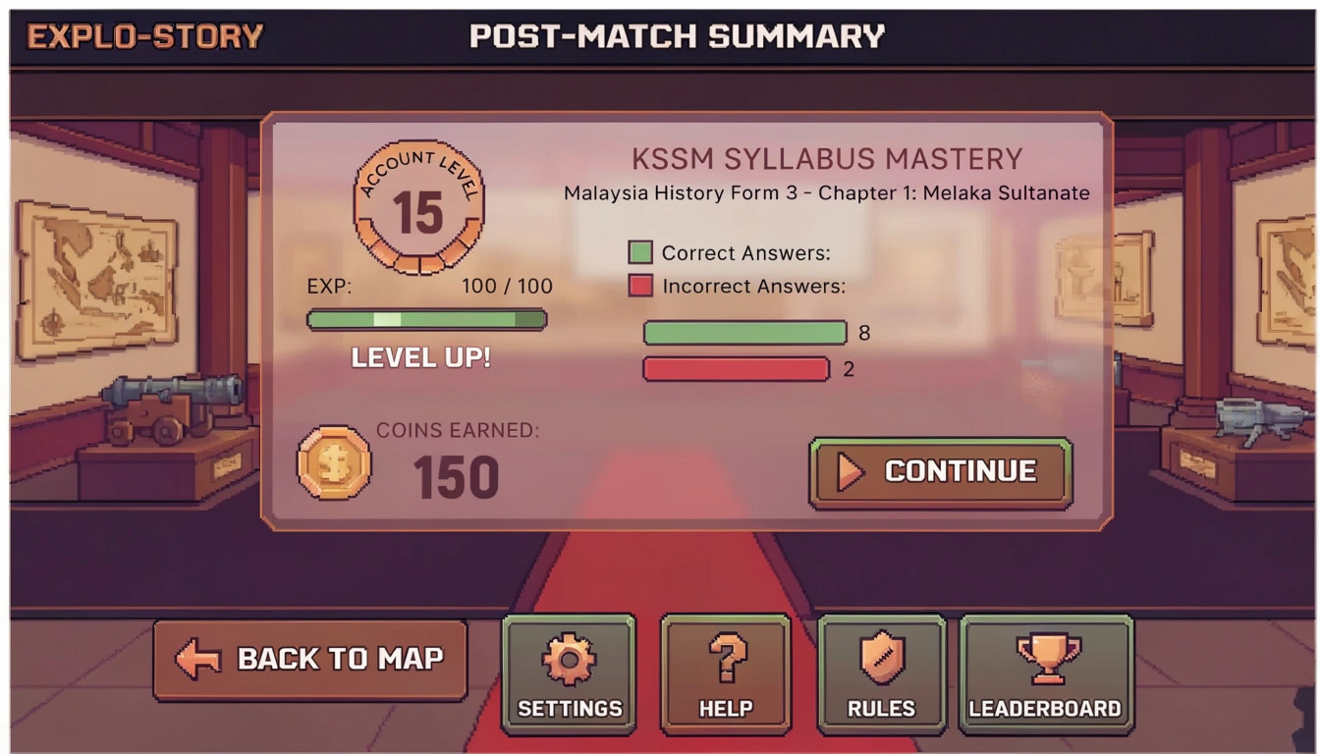 (Visualizing a 2D pixel art post-match summary screen displaying an EXP progress bar, earned coins, and history syllabus mastery statistics).
- Data Flow Diagram (DFD): Match Ends ➔ Calculate Coins & EXP ➔ Log Syllabus Mastery ➔ Write to Local Storage (user://save_data.json) ➔ Push Updates to Cloud Database ➔ Display Summary Screen.
- Database Storage: Utilizes the player's local storage (user://save_data.json) for physical save data and syncs with the MySQL 8 main game backend cloud database.
3. UI/UX Considerations
- Utilize satisfying visual and auditory feedback (e.g., ticking numbers, filling progress bars, and cheering SFX) when calculating the EXP and coin rewards to enhance player gratification.
- The KSSM Syllabus Mastery tracker should use simple, visually distinct charts to easily communicate learning progress to students and teachers.
4. Execution Notes
- Operates primarily as a background logic controller that calculates EXP and Syllabus Mastery marks after a match.
- Data is written physically to local storage (user://save_data.json) to ensure player progress is not lost if the cloud database sync temporarily fails.

Module 6: Multiplayer (PVP Room System)
1. Purpose & Functional Requirements
The primary purpose of Module 6 is to provide a network-based social mode (Phase 2) that allows players to host or join custom lobbies using alphanumeric Room Codes. It is designed to scale and support team battles ranging from 1v1 up to 4v4 using the standard trivia combat mechanics.
- FR-MUL-01 (Room Hosting): The system allows players to create custom PVP lobbies and generates alphanumeric Room Codes. Actor: Player
- FR-MUL-02 (Room Joining): The system authenticates alphanumeric Room Codes to allow players to join custom lobbies. Actor: Player
- FR-MUL-03 (State Synchronization): The system utilizes WebSocket connections or REST API polling to sync the combat state (HP, questions answered) between multiple clients in real-time. Actor: System
2. Interface Design
- Components: The Multiplayer interface features a Lobby Hub with "Host Room" and "Join Room" buttons, a text input field for the alphanumeric Room Code, and a waiting area displaying connected player avatars (supporting 1v1 up to 4v4).
- Example/Sketch: 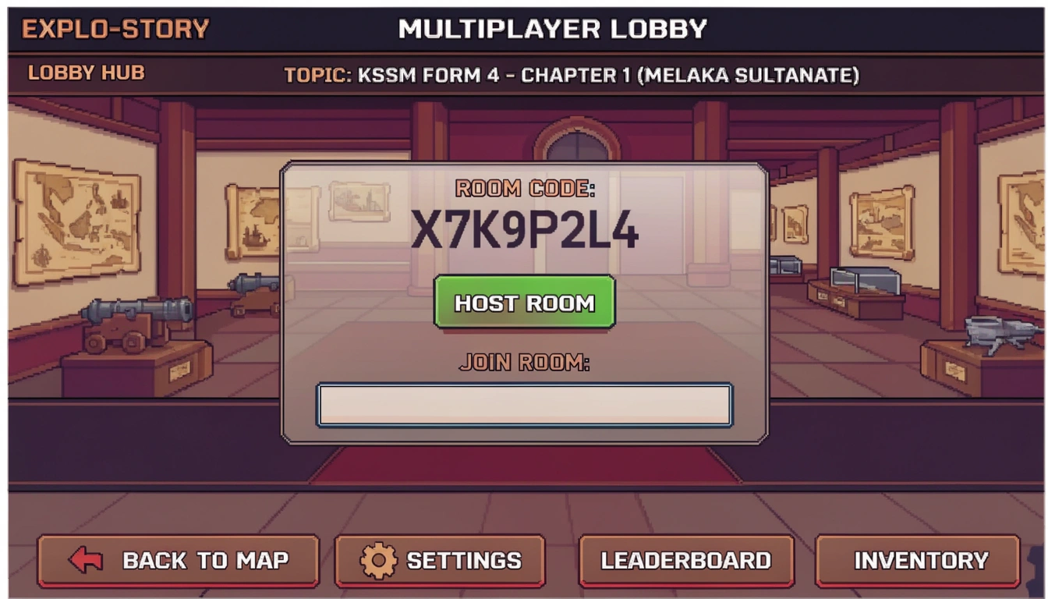 (Visualizing a 2D pixel art multiplayer lobby interface showing a Host Room button, a Join Room text input for an alphanumeric code, and a waiting area with player avatars).
- Data Flow Diagram (DFD): Host Creates Room ➔ Server Generates Room Code ➔ Client Inputs Room Code ➔ Connect via WebSocket/REST API ➔ Sync Player Avatars ➔ Start Match ➔ Real-time Combat Sync.
- Database Storage: Room data and matchmaking states are managed in the main game backend MySQL 8 database.
3. UI/UX Considerations
- The alphanumeric Room Code must be displayed in a large, legible font to easily share with friends or classmates.
- Include visual connection indicators (e.g., ping bars or "Waiting for players..." text) to provide real-time feedback on network stability and lobby status.
4. Execution Notes
- Contains the core networking architecture for the PVP Room System.
- The real-time synchronization of the combat state (HP, questions answered) between multiple clients is managed through WebSocket connections or REST API polling.

Database Design

ERD
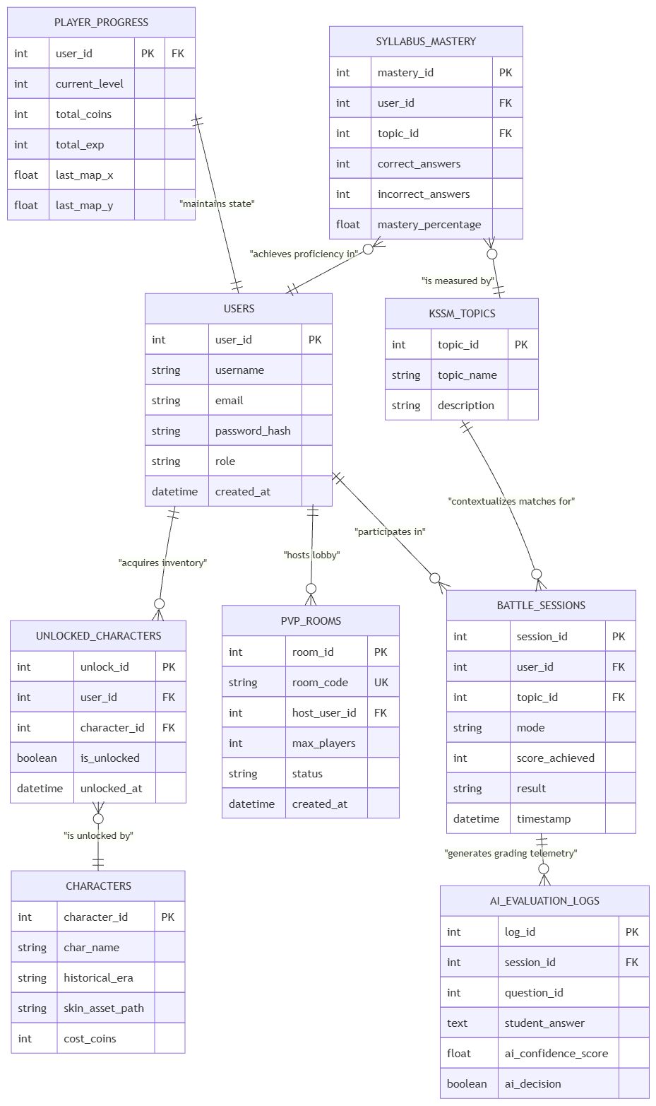

Database Table

System Overview
Explo-Story is a 2D pixel art educational RPG built on Godot 4.x and deployed via HTML5/WebAssembly. It uses a hybrid storage model, combining a fast client-side engine with a cloud-based MySQL 8.x database to manage user state and real-time multiplayer telemetry.

To support students revising the KSSM syllabus and teachers tracking progress, the database follows Third Normal Form (3NF) to minimize redundancy and maintain data integrity. Static trivia questions are stored in a local UTF-8 JSON file (trivia_data.json) to ensure rapid loading during ten-second combat loops. This keeps read operations fast, leaving relational storage for player progress, login details, syllabus mastery, and AI logs.
An Entity-Relationship Diagram (ERD) serves as the conceptual blueprint for the system. This report details necessary assumptions and highlights missing data structures that require clarification before committing to a physical schema.

Game Data Flow
Data flows through distinct functional modules in the Explo-Story client, placing specific demands on the database infrastructure.

After authentication, players enter the 2D overworld, where the client loads overall progress statistics—level, experience points, coin balance, and character coordinates. A one-to-one mapping between user identity and progress enables quick loading upon login.

Before battle, the Pre-Combat module fetches unlocked historical avatars via a many-to-many relationship. During combat, the game relies on local JSON files for questions and timers. After a match, the system writes save data locally (user://save_data.json) and syncs with MySQL to update progress, log match telemetry, and track syllabus mastery.

Entity Relationship Model
The schema is organized into logical domains for scalability. The sections below describe primary keys, foreign keys, data types, and relationships for each table.

User Identity and Access Management
A central authentication table manages roles for both students and teachers. Passwords are stored as cryptographic hashes, and web sessions use JWT tokens for validation.

Attribute | Data Type | Constraint | Architectural Description
user_id | INT | PRIMARY KEY, AUTO_INCREMENT | The immutable, unique identifier serving as the primary relational anchor for all child records.
username | VARCHAR(50) | UNIQUE, NOT NULL | The public-facing display name utilized in multiplayer lobbies and leaderboard displays.
email | VARCHAR(255) | UNIQUE, NOT NULL | The primary contact vector for account recovery and teacher communication.
password_hash | VARCHAR(255) | NOT NULL | The cryptographic hash generated during registration, fulfilling the FR-AUTH credential security requirement.
role | ENUM | DEFAULT 'student' | Distinguishes analytical privileges. Teachers require read-access to aggregated student data.
created_at | DATETIME | DEFAULT CURRENT_TIMESTAMP | An audit timestamp recording the exact moment of account provisioning.

Player Progression and State Persistence
To optimize performance and normalization, progression data is decoupled from authentication credentials. The progression entity has a 1:1 relationship with the user, storing core metrics for level-ups and economic power. This separation prevents login queries from loading dynamic gameplay stats.

Attribute | Data Type | Constraint | Architectural Description
user_id | INT | PRIMARY KEY, FOREIGN KEY | Enforces a one-to-one relationship with the authentication table, referencing users(user_id).
current_level | INT | DEFAULT 1 | The overarching numerical representation of player growth, driven by the background progression module.
total_coins | INT | DEFAULT 0 | The primary digital currency accumulated through successful combat, utilized for acquiring new historical avatars.
total_exp | INT | DEFAULT 0 | Cumulative experience points tracked to trigger automated level-ups.
last_map_x | FLOAT | DEFAULT 0.0 | The horizontal spatial coordinate used by the Godot engine to spawn the player in the 2D overworld.
last_map_y | FLOAT | DEFAULT 0.0 | The vertical spatial coordinate ensuring precise positional recovery upon subsequent logins.

Historical Character Roster and Inventory Management
The game's inventory system lets players unlock historical "Action Figures" or skins (e.g., Dato' Maharaja Lela or Rentap) to choose in Pre-Combat. In a relational database, a many-to-many pattern models this: a static metadata table defines available characters, eras, and Godot 2D pixel art asset paths, while a junction table acts as an inventory ledger recording each user's unlocked avatars..

Attribute | Data Type | Constraint | Architectural Description
character_id | INT | PRIMARY KEY, AUTO_INCREMENT | Unique identifier for each static historical character available in the game.
char_name | VARCHAR(100) | NOT NULL | The display name of the historical figure.
historical_era | VARCHAR(100) | NOT NULL | Contextual metadata categorizing the character by their historical timeline.
skin_asset_path | VARCHAR(255) | NOT NULL | The internal resource path used by the Godot client to load the correct 2D sprite textures.
cost_coins | INT | NOT NULL | The economic threshold required to unlock the character.

Attribute | Data Type | Constraint | Architectural Description
unlock_id | INT | PRIMARY KEY, AUTO_INCREMENT | A surrogate key identifying the specific transaction or unlock event.
user_id | INT | FOREIGN KEY | References the player who acquired the asset, linking to users(user_id).
character_id | INT | FOREIGN KEY | References the specific asset acquired, linking to characters(character_id).
is_unlocked | BOOLEAN | DEFAULT TRUE | A status flag confirming the asset is available for selection in the roster.
unlocked_at | DATETIME | DEFAULT CURRENT_TIMESTAMP | An audit timestamp recording when the transaction occurred.

Educational Content and Syllabus Mastery Analytics
Explo-Story uses gamification to engage students with the KSSM syllabus. While trivia questions reside in a local JSON file for speed, the database records student performance so teachers can analyze mastery and retention. Tracking topic mastery is crucial for determining when students are ready for advanced content.
Attribute | Data Type | Constraint | Architectural Description
topic_id | INT | PRIMARY KEY, AUTO_INCREMENT | Unique identifier for a syllabus category (e.g., Form 4 Chapter 1).
topic_name | VARCHAR(150) | NOT NULL | Name of the historical subject.
description | TEXT | NULL | Context for the learning objectives.

Attribute | Data Type | Constraint | Architectural Description
topic_id | INT | PRIMARY KEY, AUTO_INCREMENT | Unique identifier for a specific syllabus category (e.g., Form 4 Chapter 1).
topic_name | VARCHAR(150) | NOT NULL | The formal designation of the historical subject matter.
description | TEXT | NULL | Additional pedagogical context regarding the learning objectives of the topic.

Attribute | Data Type | Constraint | Architectural Description
mastery_id | INT | PRIMARY KEY, AUTO_INCREMENT | Unique identifier for a specific student's progress within a specific topic.
user_id | INT | FOREIGN KEY | References the student, linking to users(user_id).
topic_id | INT | FOREIGN KEY | References the syllabus category, linking to kssm_topics(topic_id).
correct_answers | INT | DEFAULT 0 | An ongoing integer count of successful historical trivia responses within the topic.
incorrect_answers | INT | DEFAULT 0 | An ongoing integer count of failed responses or timeouts within the topic.
mastery_percentage | FLOAT | DEFAULT 0.0 | A dynamically updated calculation reflecting the ratio of correct to incorrect answers.

Combat Telemetry and LLM Evaluation Logging
The combat module handles the core gameplay loop with dynamic questions, HP mechanics, and match results. To track player performance, the database logs all PVC and PVP match outcomes.

The Gemini LLM API dynamically grades open-ended history questions. To prevent AI hallucination or grading errors, an audit trail following the GRAIDES framework records raw inputs, binary grades, and AI confidence scores. Low-confidence scores trigger human-in-the-loop reviews, allowing teachers to override incorrect grades.

Attribute | Data Type | Constraint | Architectural Description
session_id | INT | PRIMARY KEY, AUTO_INCREMENT | Unique identifier for a completed combat match.
user_id | INT | FOREIGN KEY | References the primary participant, linking to users(user_id).
topic_id | INT | FOREIGN KEY | Identifies the syllabus category tested during the match.
mode | VARCHAR(20) | NOT NULL | Defines the combat context, typically 'PVC' or 'PVP'.
score_achieved | INT | DEFAULT 0 | The final numerical score derived from combat performance.
result | VARCHAR(20) | NOT NULL | The binary outcome of the match, recorded as 'Victory' or 'Defeat'.
timestamp | DATETIME | DEFAULT CURRENT_TIMESTAMP | The exact time the match concluded.

Attribute | Data Type | Constraint | Architectural Description
log_id | INT | PRIMARY KEY, AUTO_INCREMENT | Unique identifier for an individual LLM grading interaction.
session_id | INT | FOREIGN KEY | Links the AI evaluation to the broader combat session context.
question_id | INT | NOT NULL | Identifies the specific open-ended trivia prompt presented to the student.
student_answer | TEXT | NOT NULL | The raw, unedited text submitted by the player for grading.
ai_confidence_score | FLOAT | NOT NULL | A numerical metric (typically 0.0 to 1.0) indicating the LLM's certainty in its grading decision.
ai_decision | BOOLEAN | NOT NULL | The final binary grade assigned by the API (True for correct, False for incorrect).

Phase 2 Multiplayer Synchronization and Room State
Explo-Story plans to expand into multiplayer support (1v1 to 4v4, Tug of War, and Trivia Racing). This requires a code-based lobby system. The database manages room states, matchmaking, configurations, and player limits, while high-frequency live match data relies on WebSockets or game servers.

Attribute | Data Type | Constraint | Architectural Description
room_id | INT | PRIMARY KEY, AUTO_INCREMENT | The internal database identifier for the multiplayer lobby.
room_code | VARCHAR(8) | UNIQUE, NOT NULL | The alphanumeric string distributed to players for joining the match.
host_user_id | INT | FOREIGN KEY | Identifies the player who created the lobby and holds administrative rights over it.
max_players | INT | DEFAULT 2 | Defines the capacity limit, scalable between 2 and 8 concurrent connections.
status | ENUM | DEFAULT 'waiting' | Indicates the current lifecycle stage of the lobby ('waiting', 'active', or 'closed').
created_at | DATETIME | DEFAULT CURRENT_TIMESTAMP | Timestamp tracking when the room was initialized.

Performance Requirement

Web Game Performance
The client-side web application operates as an HTML5/WebAssembly export built using Godot Engine 4.x and hosted via Itch.io or a custom server.
- Frame Rate & Rendering Performance:
  - Target Frame Rate: The game must maintain a stable 60 Frames Per Second (FPS) on standard office laptops using hardware acceleration (CPU/GPU) enabled within modern desktop browsers (Chrome, Edge, Safari).
  - Resolution Scaling: Base rendering resolution is set to 1280x720 (16:9 aspect ratio). The client UI and camera must dynamically scale across varied screen sizes (mobile, tablet, desktop) without stretching, using letterboxing (black bars) when necessary.
- Asset Load & Bundle Size Constraints:
  - Maximum Build Size: The compiled HTML5/WebAssembly export must not exceed 50 MB in total file size to minimize initial load times and mitigate bounce rates on web hostings.
  - Data Parsing Speed: The client must read, parse, and load the localized trivia_data.json question bank synchronously or asynchronously at startup without screen freeze.
- Storage & Session State Latency:
  - Local Storage Sync: During Phase 1 / MVP, game state, local player progress, and active combat states must write to the browser's localStorage instantaneously.
  - Session Recovery: Web page refreshes must recover the ongoing match state from localStorage within < 1 second without loss of progress.
- Input & UI Responsiveness:
  - Input handling for both keyboard/mouse (WASD, Arrow keys, clicks) and touch-screen inputs must execute actions (character movement, MCQ option selection) with zero visual latency.

Database Performance
The architecture utilizes a dual-tier data model: lightweight JSON file structures for static trivia content, supplemented by SQL / Cloud storage for persistent user profiles and progression.
- Static Data Retrieval (JSON Engine):
  - File Encoding: All JSON data structures (including trivia_data.json) must use UTF-8 character encoding.
  - Read Latency: Local reading and parsing of the trivia_data.json file must complete within < 100 ms upon game launch.
  - Decoupling: Question data must remain decoupled from game logic, allowing updates to questions without altering or recompiling source code.
- Relational Database (SQL / Cloud DB - Phase 2):
  - User Progression Writes: Updating syllabus mastery metrics, coins, and EXP updates post-match must process asynchronously without blocking the summary screen.
  - Query Performance: Profile and syllabus progress retrieval queries (FR-PRG-03) must execute in < 50 ms under peak load.
- Data Integrity & Recovery Objectives:
  - Recovery Point Objective (RPO): Local storage backup ensures an RPO of 0 seconds during accidental browser reloads.
  - Error Handling Grace: If trivia_data.json fails to load or internet connection drops, the system must trigger polite modal notifications within < 200 ms rather than freezing or crashing.

Server Performance
Note: Phase 1 (MVP Demo) relies on single-player PVC modes running locally in-browser via static web hosting. The following specs apply to Phase 2 cloud hosting and real-time multiplayer implementation.
- Hosting & Web Server Throughput:
  - Static File Serving: Static WebAssembly/HTML5 hosting (Itch.io or DigitalOcean VPS) must handle simultaneous HTTP/HTTPS asset fetches with low response latency.
  - Bandwidth Efficiency: Content delivery must support gzipped/compressed WebAssembly binaries to sustain rapid downloads.
- Multiplayer Server & Networking (Phase 2 - PVP System):
  - Room Generation Latency: Generating a unique alphanumeric Room Code and initializing a PVP lobby must execute within < 200 ms.
  - Real-Time Synchronization (Tarik Tali, Relay, Racing Modes): Combat states, countdown timers, and team progress must synchronize across players (up to 4v4 matches) with a network update tick rate of at least 20 Hz to 30 Hz.
  - Network Latency Ceiling: Room state synchronization must remain stable under client-to-server latencies of up to 150 ms.
- AI Service Processing (Phase 2 - Open-Ended Marking Engine):
  - Evaluation Response Time: External AI Engine API calls (FR-BTL-07) for marking open-ended student text inputs must complete evaluation and return scores within < 2.0 seconds to avoid stalling gameplay loops.

Usability Requirement

Interface Design
- UR-ID-01 (Visual Consistency & Adaptive UI): The core 2D pixel art game world (exploration and combat scenes) will be strictly locked to a 1280x720 resolution with a 16:9 aspect ratio using a SubViewport to guarantee the art remains perfect and un-stretched. Meanwhile, the User Interface (HUD and mobile controls) will utilize Canvas Expansion to dynamically adapt and anchor to the physical screen dimensions of any desktop, web, or mobile browser, preventing distorted graphics while maximizing usable screen space for touch controls.
- UR-ID-02 (Input Validation): Text input fields on the Login and Registration screens will provide immediate visual feedback, such as displaying a red outline or warning text if the user types an incorrect format.
- UR-ID-03 (Action Prevention): To prevent API spamming and user frustration, primary action buttons (like "Log In" or "Sign Up") will remain grayed out and disabled until all required fields are correctly filled.
- UR-ID-04 (Selection Clarity): Selected elements will feature obvious active states; for example, chosen historical Action Figures will have a glowing border outline to eliminate any confusion about the player's active choice.
- UR-ID-05 (Locked Content Indicators): Any locked characters or content will be silhouetted in black or clearly displayed with a padlock icon, communicating immediately that they are unavailable.
- UR-ID-06 (Multiplayer Legibility): In the PVP lobby, alphanumeric Room Codes will be displayed in a large, highly legible font so players can easily read and share them with friends without mistakes.

Control Design
- UR-CD-01 (Universal Inputs): Player controls will seamlessly adapt to whatever device is being used, supporting keyboard shortcuts (WASD), mouse clicks, and touch screen controls for mobile and tablet users.
- UR-CD-02 (Camera Smoothing): The 2D camera will smoothly follow the player's character during Overworld map exploration to prevent jarring movements and motion sickness.
- UR-CD-03 (Collision Forgiveness): Interactive assets, such as buildings in the Overworld, will use generous collision boxes (Area2D) so that players can easily trigger UI popups without needing pixel-perfect positioning.
- UR-CD-04 (Menu Navigation): All interface screens will feature clear and consistently placed "Back" or "Close" buttons, allowing players to easily exit sub-menus or cancel room joining without feeling trapped.

Feedback and Signs
- UR-FS-01 (Action Audio Cues): Every button press, menu transition, and combat action will be accompanied by satisfying, high-quality sound effects generated via ElevenLabs to provide instant auditory confirmation.
- UR-FS-02 (Combat Reinforcement): During Trivia Combat, submitting a correct answer will instantly trigger an attack animation and reduce the enemy's HP, giving the player immediate positive reinforcement.
- UR-FS-03 (Time Urgency): The 10-second combat timer will use prominent visual signs, such as pulsating or turning red in the final seconds, to clearly warn the player that time is running out.
- UR-FS-04 (Error Recovery): If an internet connection drops or a JSON file fails to load, the system will display a clear, friendly error message (e.g., "Failed to load questions") instead of freezing or crashing the game.
- UR-FS-05 (Network Status): The multiplayer lobby will provide visual connection indicators, such as "Waiting for players..." text, so users understand the current matchmaking and network status.
- UR-FS-06 (Progression Rewards): The Post-Match Summary will use engaging feedback like filling EXP bars and animated coin counters to make leveling up feel rewarding and clear.

Learnability and Onboarding
- UR-LO-01 (Guest Mode Access): To ensure a perfect first impression, a "Guest Mode" hyperlink will allow players to immediately try the game without going through the friction of creating an account first.
- UR-LO-02 (Safe Preparation Phase): The Pre-Combat Preparation module will act as a learning bridge, allowing players to read historical lore snippets and review stats without any time pressure before entering a match.
- UR-LO-03 (Clear Data Analytics): The KSSM Syllabus Mastery tracker will use simple, visually distinct charts so that both students and teachers can instantly understand cognitive retention and learning progress.
- UR-LO-04 (Role-Based Clarity): Teachers and Students will have distinct, easily selectable roles during registration, ensuring that users only see the dashboard features relevant to their needs.

Accessibility
- UR-AC-01 (Performance Optimization): The total game file size will be strictly kept under 50MB, ensuring that the game loads in under 5 seconds even for players using slow school internet connections or basic smartphones.
- UR-AC-02 (Audio Controls): The audio management system will include a highly visible mute/unmute button so players can quickly silence background music (BGM) in quiet environments like libraries or classrooms.
- UR-AC-03 (Privacy Masking): All password input fields will be masked with asterisks (*) to ensure user privacy is protected when logging in around other students.
- UR-AC-04 (Data Fallback): Player progress will be physically saved to local storage (user://save_data.json) to guarantee that no hard-earned EXP or coins are lost if the cloud database connection temporarily fails.
- UR-AC-05 (Cross-Platform Reach): By exporting to HTML5/WebAssembly, the game will be universally accessible on Windows, macOS, Linux, Android, and iOS directly through web browsers without requiring app downloads.

Visibility
- UR-VI-01 (Persistent HUD): Crucial stats like the player's Avatar icon, Level, EXP progress bar, and Coin counter will be anchored to the top CanvasLayer, ensuring they are always visible regardless of camera movement.
- UR-VI-02 (Combat Clarity): In the combat mini-game, HP bars, the countdown timer, and the trivia question dialogue box will be clearly separated from the 2D background environments so players can read questions easily.
- UR-VI-03 (Interactive Asset Markers): Interactive points of interest in the Overworld map will display floating exclamation marks (!) above them, making it obvious to the player where they need to go to start a game mode.

Scalability Requirement

User and Concurrency Scaling
- SR-UC-01 (Web-Based Distribution): By exporting the Godot Engine 4.x project to HTML5/WebAssembly, the game eliminates client-side installation bottlenecks and can be instantly accessed by a massive number of simultaneous users directly through their web browsers.
- SR-UC-02 (Infrastructure Migration): The game architecture is designed to launch on shared hosting (Microsoft Server / GitHub Pages) for the 8-week prototype phase, ensuring it can be seamlessly migrated to dedicated or scalable cloud servers to handle increased web traffic as the player base grows.
- SR-UC-03 (Multiplayer Elasticity): The Phase 2 Multiplayer (PVP Room System) is built to scale its network communication, supporting variable lobby sizes from 1v1 up to 4v4 team battles using WebSocket connections or REST API polling to sync combat states between multiple clients.

Database and Content Scaling
- SR-DC-01 (Backend Database Growth): The application utilizes MySQL 8.x for its main game backend, providing a highly scalable, relational database structure to securely manage an infinitely expanding volume of user accounts, player profiles, and progression data.
- SR-DC-02 (Decoupled Trivia Architecture): Trivia questions are deliberately isolated into a lightweight JSON file (trivia_data.json) that acts as a local database. This allows developers or teachers to continuously add thousands of new KSSM history questions without ever needing to alter the core game code, recompile the game, or overload the SQL database.
- SR-DC-03 (Automated Grading Scalability): The integration of the Gemini API allows the system to evaluate the factual accuracy of open-ended text answers in real-time. This scales the game's cognitive assessment capabilities, handling infinite variations of student inputs automatically without requiring manual grading from teachers.

Modular and Architectural Scaling
- SR-MA-01 (Scene Encapsulation): The game employs Godot's composition-based, hierarchical paradigm, where components are organized into a strict Scene Tree. Because Scenes are localized, encapsulated branches, developers can create and inject entirely new modules or mini-games without altering or breaking existing scenes.
- SR-MA-02 (Decoupled Event Communication): To ensure that adding new features does not jeopardize the existing system, the game uses an event-driven communication model called Signals (the Observer design pattern). Nodes emit signals rather than maintaining direct hard-coded references to each other, meaning new modules can be plugged in and subscribed to events without creating rigid, system-breaking dependencies.
- SR-MA-03 (Efficient Memory Management): The architecture strictly separates execution logic (Nodes) from static data (Resources). As the game scales with new historical characters, environments, and high-quality audio generated via Suno AI and ElevenLabs, these passive Resource containers can be referenced by multiple nodes simultaneously, ensuring the game remains highly memory-efficient as assets multiply.

Maintainability Requirement
To ensure the application remains extensible, bug-resistant, and adaptable to future educational curricula without incurring prohibitive technical debt, the following maintainability requirements must be implemented:
- Modular Scene Encapsulation: The architecture must utilize Godot's hierarchical Scene Tree to build encapsulated, single-responsibility modules, allowing new interface elements or gameplay features to be composed without introducing breaking changes to existing systems.
- Decoupled Event-Driven Communication: Components must strictly avoid rigid, hard-coded path dependencies. Communication across the application must be governed by the Observer design pattern via Godot signals, utilizing an Event Bus Singleton for distant nodes to ensure the codebase remains flexible and highly debuggable.
- Separation of Logic and Data: Active execution logic must be strictly separated from static configuration data through the use of Godot resources, ensuring highly efficient memory management for media assets and statistical variables.
- Externalized Content Architecture: All educational content, including trivia questions and grading rubrics, must be isolated in lightweight, externalized JSON files, explicitly allowing educators to update or modify massive volumes of content without altering core executable code or requiring binary recompilation.
- Backend Modularity and Version Control: The cloud infrastructure must adhere to a strict MVC architecture with isolated functional modules to allow independent scaling of services. All source code and asset iterations across both client and server must be maintained via version control systems to facilitate safe, concurrent team collaboration.

Security Requirement
To protect user privacy, defend against API exploitation, secure local storage within a web environment, and ensure the integrity of AI-assisted grading, the following security requirements must be implemented:
- Authentication and Access Management: The system must implement robust Role-Based Access Control to clearly separate student, teacher, and administrative privileges. Passwords must be protected using modern cryptographic hashes prior to database storage, and client-side password input fields must be visually masked.
- Session and Transport Security: Web sessions must utilize JSON Web Tokens to validate state and explicitly prevent Broken Object Level Authorization vulnerabilities. All web traffic between the WebAssembly client and the backend must be encrypted over verified TLS/SSL connections.
- Client-Side Persistence Protection: Data written to the local HTML5 IndexedDB file system must be cryptographically protected using AES-256 encryption via Godot's FileAccess class, validated via HMAC-SHA256 integrity signatures, and committed using atomic write operations to prevent corruption.
- LLM Security Constraints: The integration of the Gemini API must be secured against Prompt Injection (OWASP LLM01) through zero-trust input sanitization and strict system prompt boundaries. It must be secured against Insecure Output Handling (OWASP LLM02) by enforcing JSON schema responses and strict client-side parsing validation.
- Audit Trails and AI Fallbacks: The system must meticulously log all raw inputs and confidence scores generated by LLM interactions. This comprehensive audit trail is required to detect AI hallucinations and malicious manipulation, serving as the foundation for a Human-in-the-Loop protocol that allows educators to manually oversee and override anomalous algorithmic grading. Furthermore, all critical user actions and system changes must be recorded in centralized backend audit logs to ensure total operational accountability.

Part I: Maintainability (Easy Updates & Scaling)
To ensure the codebase remains clean and new KSSM history content can be added without breaking the game, the architecture avoids rigid coding in favor of modular systems.
- Lego-Block Architecture: Instead of complex inheritance trees, the game uses Godot's Entity-Component system. Behaviors (like movement, health, or UI) are isolated into independent nodes and nested scenes. You can change the UI or swap out a movement component without breaking the core game.
- Event-Driven Communication: Systems talk to each other using Godot's Signals and a global Event Bus. When a player takes damage, the game simply broadcasts a signal. The health bar listens for that signal and updates itself. This prevents game systems from being dangerously tangled together.
- External JSON Syllabus: Educational content is never hard-coded. All trivia questions are stored in a separate JSON file. Teachers can update or add thousands of questions just by editing the text file, requiring zero changes to the actual game code.
- Decoupled Backend: The static game client is hosted on GitHub Pages (kept under 50MB for fast school loading), while user data is managed by a separate MySQL 8.x database in the cloud. You can upgrade the database without touching the game client.
- AI Asset Pipeline: The project strictly uses tools like Claude Pro, Midjourney, and Suno AI to generate code, art, and music efficiently.

Part II: Security (Anti-Cheat & Data Protection)
WebAssembly games run in the browser, meaning the client is easily exposed to hacking, save-editing, and AI manipulation. The architecture defends against this on multiple fronts.
- Tamper-Proof Local Saves: Browser storage (IndexedDB) is unencrypted and easily edited by players to cheat. The game encrypts save files using AES-256 and adds a digital signature (HMAC-SHA256). If a student tries to alter their save file, the cryptographic signature won't match, and the tampered file is immediately rejected.
- Safe API & Authorization: All network traffic runs over strict HTTPS. Once logged in, the game uses JSON Web Tokens (JWT) to verify identity, ensuring a user can only access their own data. Passwords are cryptographically hashed in the database.
- AI Prompt Injection Defense: The Gemini API is used to grade open-ended answers. To prevent students from typing commands that trick the AI into giving them a perfect score (Prompt Injection), student text is sanitized and treated with zero-trust. The AI is locked into a strict system prompt that ignores user commands.
- Insecure Output Prevention: To stop the AI from accidentally generating malicious code that breaks the game (Cross-Site Scripting), the Gemini API is forced to reply only in a strict JSON schema. If the output isn't perfect JSON, the game rejects it entirely.
- Human-in-the-Loop: Because AI can hallucinate, all AI grades and student inputs are logged in the database. If the AI flags low confidence, a teacher can review the log and manually override the grade to ensure perfect accuracy.

